西赛尔

XSE - 903 - B comprehensive surgical electric bed
(gynecological examination bed)

Instruction for use

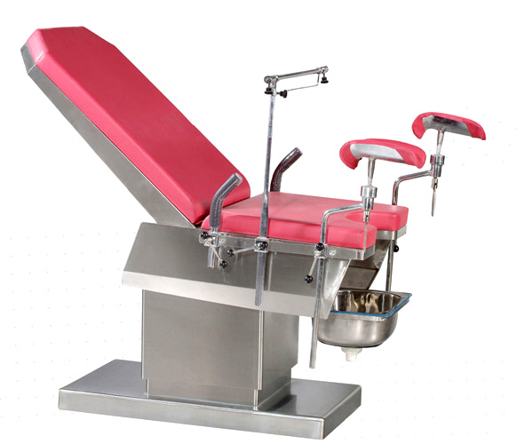

Harbin west self medical equipment co., LTD

No.26 Spring Street, Nangang District, Harbin Postal Code: 150030 Tel / Fax: (0451) 85923767

XSE-903-B gynecological examination bed

One, Overview:

This bed is electrically controlled stainless steel inspection surgical equipment. Its unique design is aimed at urology, gynecological examination and testing, you can directly adjust the height and angle for the patient to be successfully inspected and surgery.

Two, Main Technical parameters:

1, Displacement：Up / down height590-890mm
2，Backrest angle：have
3，Head low angle feet high angle：have
4，Head high angle, feet low angle：have
5，Left and right side：have
6，noise：Mute, less than 35 dB
7，Bed width: In the range of 650-750mm
8，Bed length: ≥1700mm
9，Load-bearing：≥140 kg
10，Drive mode：electric
11，Fixation of the body and legs: have
12，Head frame, arm plate, and fixed：have

Three. Main technical performance

1, the use of DC motor movements, mechanical and electrical transmission structure, safety voltage control.
2, table height adjustment: table height can be adjusted between 620-820mm, just press the button, up and down to adjust to achieve the desired height.

Four. Standard configuration

1, Curtain frame, 2, a universal leg care, 3, a pair of handles, 4, dirt basin, 5, a pair of handrails, 6, activities mattresses

Five. Use of maintenance and maintenance
1, the exposed part of the bed is stainless steel, no rust, should be cleaned after use.
2, the rotating parts and sliding parts should be regularly lubricated.
3, please use the conventional method of disinfection of medical devices before use.

Six. contact information

Tel: 0451-85923767
Fax: 0451-85923767
Address: Nangang District, Harbin Spring Street on the 26th
Zip code: 150030

Harbin west self medical equipment co., LTD

